GROUP 3

# https://alln-extcloud-storage.cisco.com/ciscoblogs/lecture-hall1-550x303.jpg

# CSE5ITP N E T W O R K P R O J E C T DEVELOPMENT

HIGH DENSITY WIRELESS DESIGN

# 

TEAM MEMBERS:

Bhargavi matam: 19844060

Ram Saran Reddy Lingala: 19808762

Rohith Jamakayala: - 19837976

Rajasekhar Yannam: - 19600257

TABLE OF CONTENTS:

1. Overview………………………………………………………… 3
   1. In scope/out scope 4
   2. Stack holders 5

2.Communication plan 6

3.Risk analysis 8

4. PHYSICAL SITE SURVEY 9

* 1. Potential challenges and interferences 9
  2. Tools 10

5.Tools (software used) 10-13

6.SITE SURVEY 13

* 1. Details of SNR, Signal coverage, SNIR 17
  2. Channel interference. 22
  3. Signal strength 26
  4. Throughput 31
  5. Interference graphs 35

7. HD BANDWIDTH ESTIMATION 41

8. PROBLEM IDENTIFIED 42

9. POTENTIAL SOLUTION 42

10.COST ESTIMATION 43

1.Overview

Here is the report to have a clear understanding of the Wireless network in the East Lecture theatre halls 5 & 6 which we have been allocated to analyze and debug the errors if any. Since the number of wi-fi users are increasing day by day we need to update the network on timely basis. In order to meet the existing network demand we need to increase the coverage and strength of the network. As we are in a area where there is a high network demand since each and every student and faculty are utilizing the Latrobe network the network will have a high pressure over it which results in the network issues namely signal strength, signal interference, noise, efficiency, coverage etc.,

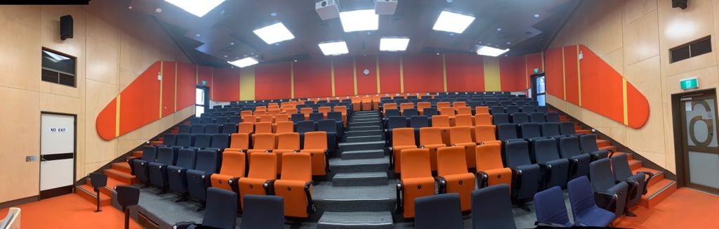

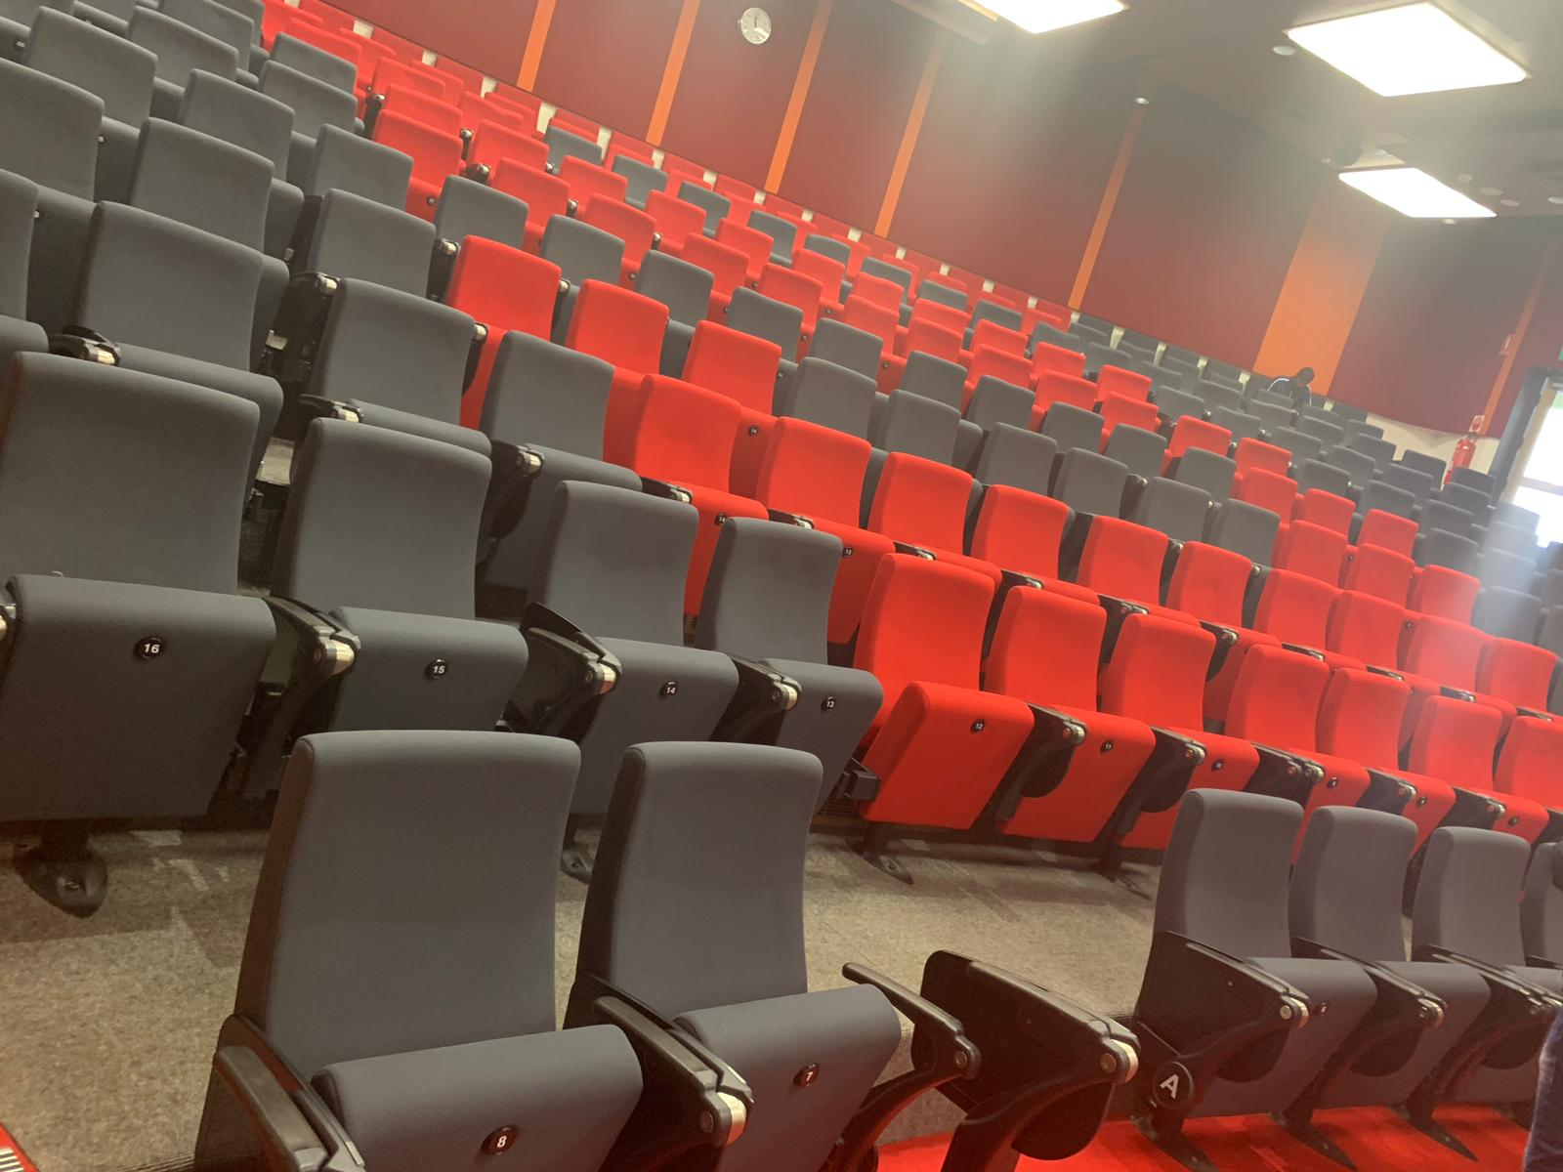

These are the Lecture theatres that are given to us. East lecture theaters 5 & 6 . East Lecture theatre 5 has total seating capacity of 199 and with three access points. The main challenges are wooden walls, cutting on cable, wireless cams. East Lecture theatre 6 has a total seating capacity of 200 and two access points.

We also need to focus on the factors that influence the network to undergo the above issues which includes number of clients, number of Ap’s and position of Ap’s. As we are dealing with the high density environment we need to know the on-peak and off-peak timings of the particular area and the signal coverage and strength of the existing network. So, in order to know the existing network elements we have to conduct a site survey of the location that has been allocated to us and analyze the network to find any issues existing in the network.

In order to perform above tasks it takes a minimum of 8 weeks of time and a maximum of 10 weeks which in turn depends on the area and issues to be addressed in the network. It takes a minimum of 1 and a maximum of 2 weeks of time to perform the site survey to analyze the peak and off-peak of the location and a minimum of 2 and a maximum of 4 weeks of time to perform the survey using different site survey tools. To compare and analyze the network it takes 2 weeks of time. In order to perform the above mentioned tasks we need to have a project leader, survey analyst, Wireless expert and a Project designer.

1.1 IN SCOPE/OUT SCOPE:

High density WIFI is majorly created when we have more than 30 clients in a particular area. In this process the available frequency band is majorly divided depending on the number of users. Generally, it is established in the auditoriums, shopping centers etc. and many other gatherings when there is huge mass.

In this access points play a major role. Access points are those which convert the available frequency into some required frequency range and tries to maintain the same frequency throughout the area. All these access points can be monitored by using a system where we can monitor and regulate the frequency as per the need. In few cases, in which we can see few sudden changes in the frequencies and some other issues. So, all these can be monitored by using a system.

In this project the main challenges are:

Number of clients which is not predictable. And Maintaining the balanced network without overflow [bandwidth directly proportional to data speed] and

overload. Also Monitoring the WIFI continuously with high frequencies and maintaining the minimum number of access points through a software driven network and by using some network concepts. We can maintain the network by using some basic concepts like radio monitoring, traffic shaping and load balancing.

1.2 STAKE HOLDERS:

Stake holders are individuals or may be organizations who combinedly work on a project. In order to achieve the Project goals, the participation of stake holders plays an important role. Stake holders analysis is to provide a project manager, about the project team and the people who are interested in the project. So the Project leader is responsible for the success or failure of the project. It is a process of systematically collecting and analyzing quality information to determine whose interests should be taken into account to develop the project. Different Stake holders have different attitudes, perspectives, level of interest and and information. So every project stack holders are unique.

Stake holder analysis is of two types called primary and secondary stakeholders. Primary stack holders are involved in the development of project. It includes gathering opinions, estimating resources for project, communication plans etc. In our project the primary stake holders are Bhargavi matam (Project leader) she was responsible for managing the work of the team and utilizing the resources in an effective way, Ram Saran Reddy Lingala (survey analyst) he is responsible for designing and analysing the network, Rohith (wireless expert) he is checking the wireless issues, Rajasekhar Yannam (Project designer) he is responsible for preparing the plan of action and for future plan.

Secondary stake holders have and indirect relationship with project. They are involved in network specialist information and communication technology, Users (students, staff, guests). These secondary stakeholders are influencer and supporters of our project. These secondary stake holders are also acting as advisors who are guiding us in right directions by helping us with their own ideas and suggestions.

2.COMMUNICATION PLAN

A project Communication plan is a step by step process for carrying out a project from beginning to end of the project. But these are just the formal meeting in the college.

Group meeting 1: The main goal was getting to know the team members and notifying each group members role. The result of the meeting was assigning the group members roles as follows, Bhargavi Matam (Project leader) she was responsible for managing the work of the team and utilizing the resources in an effective way, Ram Saran Reddy Lingala (survey analyst) he is responsible for designing and analyzing the network, Rohith (wireless expert) he is checking the wireless issues, Rajasekhar Yannam (Project designer) he is responsible for preparing the plan of action and for future plan.

Group meeting 2: In this meeting we discussed on the detail project plan. We prepared the document on the introduction of project, scope of project. In this project the main challenges we predicted are Number of clients which is not predictable. And Maintaining the balanced network without overflow [bandwidth directly proportional to data speed] and overload.

Group meeting 3: In this meeting we discussed on the floor map given to us. Group members divided survey work and went on the survey at different times of a day and gathered information on AP’S, switch racks, how many users at a time. We also gathered information note down information on peak, off peak and average time.

Group meeting 4: In this meeting we made a research of different tools that are required for the project. We made a documentation on different tools specifying their specifications. Tools which we finalized out of various tools available in the market are :

Ekahau site survey is the tool that helps with the planning, site surveying, analyzing and troubleshooting the wi-fi networks. Now a days most of the multinational companies are using this tool to design their networks.

Visiwave is a tool which helps in knowing the things that are happening in our 802.11 network. It provides information and visualizes the radio waves and also helps in knowing how effective the Wi-fi reach is. The complete information regarding these tools are further explained.

Group meeting 5: During this period, we made a site survey using different software applications observing the required parameters like signal coverage, snr, throughput, adjacent cochannel interface, number of users connected etc.

Group meeting 6: Documenting the results obtained from software and updating our previous documents, preparing presentation.

Group meeting 7:In this meeting we had a final discussion on billing of materials, documented cabling and on how to survey the students at different times to get a clear view on bandwidth usage and a complete budget plan for the completion of the project and we also discussed on configuration changes.

Group meeting 8: In this particular meeting we discussed on the changes and updating our final report and also made our final presentation.

3. RISKS AND ISSUES

In a wireless network design, network security is one of the most important factors. In order to have security we need to give access only to authorized persons so that we can even reduce the number of users connected to a network which helps in a reduced use of network and maintain a better network speed. We also need to have a scalable security solution in order to protect the network during very high user count. Other thing that may affect the signal is the interference of the signals so we need to create smaller cells in order to reduce the output power of access points so that the RF signals will not propagate far so that it will reduce the adjacent and co-channel interference of the signals. we can also use any attenuating materials so that the signal power is reduced making it to avoid the interference of signal. Moreover, we also need to setup access points at proper locations and maintain distances in order to avoid interference.

When we are designing a wireless network for a high density environment Noise and interference are the most common problems that any network engineer has to overcome. So there comes this idea of using different channels in order to avoid co-channel interference. Since we have two different frequency ranges 2.4Ghz and 5Ghz which operate in different channels we will have more chances of co-channel interference. So in order to avoid co-channel interference we need to configure the Aps to use different channels. we can configure the access points with different non-overlapping channels being 23 for 5Ghz network and 3 channels(1,6,11) for 2.4Ghz network. We also need to consider the physical risks that occur to network which includes the card access points near the entry to lecture theatres and the automated sensors that are operating in the lecture theatres.

4. PHYSICAL SITE SURVEY

4.1 POTENTIAL CHALLENGES AND INTERFRENCES

The potential challenges that we have in these lecture halls are the card access points near the entry points of the theatres, the automated sensors present in the lecture theatres to turn-on and turn-off the lights in the theatres automatically and the sound bars that operate at 2.4Ghz. The above mentioned being the physical challenges while there are other challenges that we need to address are the co-channel and the adjacent channel interferences. Since the access points are being operating at two different frequency bands which are 2.4Ghz and 5Ghz we will come across different interferences while they are using different channels for communicating with the clients and to avoid co-channel interference. But since there are multiple access points in a lecture theatre we need to carefully configure them to operate at different channels otherwise they will end up having a huge co-channel interference which in turn reduces the Signal-to-noise ratio increasing the noise in the signal. And also since all the lecture theatres are adjacent to each other there are chances that a signal from an adjacent lecture theatre operating at same frequency and same channel to interfere with signal in the adjacent theatre. So, in order to avoid this we need to configure the Aps in the adjacent theatres to operate in different channel when operating at a least distance in order to avoid interference.

5. Tools (software used)

Ekahau:

Ekahau is the survey tool that is used for planning, surveying, analyzing and troubleshooting the Wi-Fi networks. Ekahau is the software that helps analyze the 802.11 network. In this software we are allowed to perform a survey by deploying the floor map and scaling the map manually and building a wall and also building a region in which we want to measure the signal constraints. We can perform a continuous and a stop and go survey using this software. The advantage with this software is that it helps analyze the 2.4Ghz and 5Ghz networks separately. We can have a heat map of the coverage area, signal strength, interference, signal to noise ratio, noise map and we can also check the health of the signal and the issues present in the network. We can also see if there are any Bluetooth devices existing in the network that cause the interference in the network. It also shows the number of access points and their locations in the map. Ekahau supports 802.11a/b/g/n/ac/ax networks. Ekahau supports Windows, Mac operating systems.

Pros:

Supports only one adapter in stop and go mode

Can perform survey faster in the continuous mode

Can differentiate heat maps between 2.4Ghz and 5Ghz networks

Can perform the survey in any path

Can analyze the interference using the graphs

Provides a trial version of the software for free of cost

Cons:

We cannot find all the AP’s in the continuous survey mode

It does not provide exact information on security of the Wi-Fi

Acrylic Wi-Fi:

Acrylic Wi-Fi has four versions: Acrylic Wi-Fi Heat maps, Acrylic Wi-Fi Professional, Acrylic Wi-Fi Home and Acrylic Wi-Fi LEA. It is basically used to design, analyze and detect any errors in the network if any. Acrylic Wi-Fi home and professional are just used to analyze the interference in a 2.4Ghz and 5 Ghz networks. Acrylic Wi-Fi heat maps are used to design and plan a new Wi-Fi installation and analyze any existing network. Acrylic Wi-Fi heat maps are used to generate the heat maps of coverage of the network and it also helps generate the detailed report of the network. It is only compatible with the Windows operating system.

Pros:

Helps analyze a network based on the interference graphs and heat maps generated

Can identify all the access points in the network and even the remote networks

Get a detailed quality of assessment.

Identifies any network problems and improves the network performance.

Cons:

Since it is only compatible with the Windows operating system it doesn’t work in Mac OS it has become a drawback for many users using Mac OS.

This software cannot access network that has security.

Graph quality varies.

VISIWAVE:

Visiwave is the software that helped us to analyse the 802.11 network. Using this software we analysed the number of access points present in each lecture theatre and were able to create a map to know the exact Wi-Fi reaching capability. In this software first we need to create a project and deploy the floor plan of the area where we are expected to do the survey. After deploying the floor map we need to set the scale manually by measuring the scale that is already present in the floor map. This software allows us to conduct the survey in different modes namely point-to-point, continuous and GPS. While conducting the survey we need to collect the points very close to each other in order to cover the whole lecture theatre and to have a very accurate measure of the results. When we are doing a point-to-point survey we will only be able to collect information regarding only one point at any instance. It only allows the user to move to a next point only after gathering the detailed signal characteristics at that particular point. This software also helps in creating the heat map of the survey to make a detailed analysis of the results obtained from the survey. We can also include the AP locations and data points and labels in order to have a clear understanding of the results. We can also divide the survey map in to different cells and measure the data rates and throughput and also the channels operating at each cells can be analysed separately. This software also allows us to add all the required information to a PDF file making a document of the survey results that we obtained.it operates both on windows and Mac operating systems.

Pros of Visiwave:

Can visualize the number of Aps operating in the lecture theatre

It is very Economical, allows us to use trial version at a free of cost

Creates heat maps for easy visualizing of network

Allows us to visualize the security mappings in the network

Helps to view the overview of the network present in the site

Cons of Visiwave:

Cannot perform a active and a passive survey at the same time.

Cannot detect walls on its own so that we can visualize the signal outside the area

We cannot differentiate between a 2.4 Ghz and a 5Ghz signal

It will not support multiple external adapters

Cannot perform prediction calibration

6 SITE SURVEY RESULTS

Site survey is the most important and interesting part of the project. It is the visual inspection of the site and helps us in understanding the existing network. Before starting a site survey, we need Building layout, Access point location, Software used, time of peak and off-peak.

According our physical site survey we observed a peak on Wednesday in ELT6 with a student count of 90 writing a quiz, so there were 90 laptops which were accessing the Latrobe LMS page at that time.

In this radio frequency site survey, we did walk testing, diagnosis of an existing wireless network, and also the level of service required.

The below tabular reading are the decent reading where we had higher data usage and people. We took the site reading every day but the people attending the lecture are below 10 so we are not putting them all.

As far we consider these are the two days we had seen good number of people attended the lecture. Especially there was a lecture named asthma Australia where we had 46 people but the data rates are very high which are shown in the graphs

|  |  |  |  |  |  |
| --- | --- | --- | --- | --- | --- |
|  | Day | Location | Time | Number of students | Number of devices |
| Peak time | Wednesday | Elt 5 | 12:00pm | 65 | 53 (sub: asthma australia)  (28 laptops, 39 mobiles approx.) |
| Off-peak |  | Elt5 | 3:00pm | 11 | 25(2pcs,11 mobiles,10 laptops,2 watches) |
| Off-peak |  | Elt5 | 9:00am | 6 | 17(2pcs and 12 mobiles,3 laptops) |
| Peak time | Wednesday | Elt6 | 2:00pm | 23 | 33 (2pcs,23 mobiles,8 laptops) |
| Off peak |  | Elt6 | 9:00 am | 7 | 11 (2 pcs,7 mobiles,4 laptops) |
| Off peak |  | Elt6 | 11:00am | 5 | 8 (2 pcs,5 mobiles,1 laptop) |
| Peak time | Monday | Elt 6 | 2:00pm | 31 | 33(2pcs and 31 phones) |
| off peak |  | Elt 6 | 11.00am | 11 | 17(2pcs 11 phones,4 laptops) |
| Peak  time | Monday | Elt 5 | 11:00am | 21 | 34 (13pcs and 21 phones) |
| Off  peak |  | Elt 5 | 2:00pm | 7 | 17(2 pcs,7 mobiles,8 laptops) |
| Peak  time | Tuesday | Elt 6 | 1:00pm | 13 | 16(2 pcs,13 mobiles ,1 pc) |
| Off  peak |  | Elt 6 | 9:00am | 6 | 11(2 pcs,6 mobiles,3 laptps) |
| Off  peak |  | Elt 6 | 11:00am | 5 | 12(2 pcs,5 mobiles,5 laptops) |
| Peak  time | Tuesday | Elt 5 | 1.00pm | 23 | 35(2pcs,23 mobiles,10 laptops) |
| Off  peak |  | Elt 5 | 10:00am | 7 | 10(2 pcs,7 mobiles,1 laptop) |
| Off  peak |  | Elt 5 | 3:00pm | 13 | 19(2 pcs,13 mobiles 4 laptops/0 |

EAST LECTURE THEATER 5:

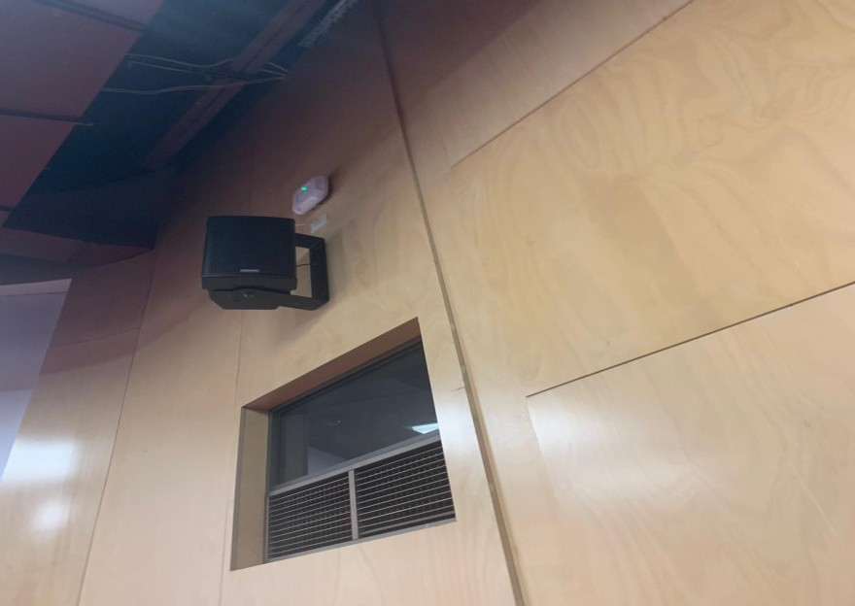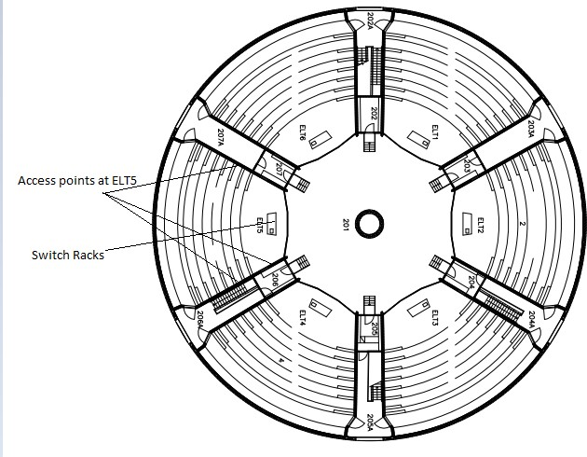

As per our survey in the East lecture theatre 5, the total seating capacity of this hall was 199 with four entry/exit doors and with three access points. As two of them are located on each side walls and the third one was mounted on the right-side wall above the speaker. In this hall the switch racks are provided near the podium under the desk. This was the third access point.

EAST LECTURE THEATER 6:

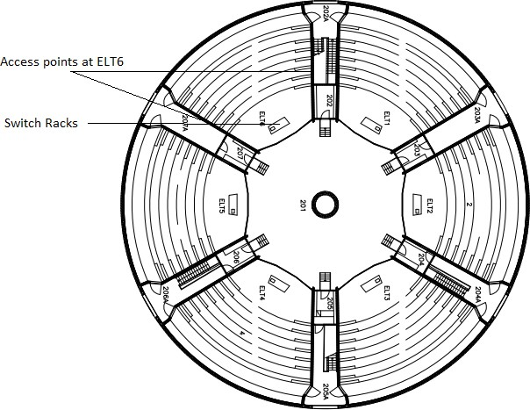

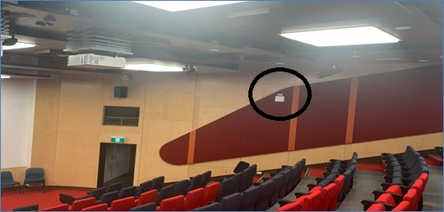

As per our survey in the East lecture theatre 5, the total seating capacity of this hall was 199 with four entry/exit doors and with two access points. As two of them are located on each side walls exactly opposite to each other. In this hall the switch racks are provided near the podium.

If we look into the peak, off-peak and average times in each hall there are different times where people have classes so each class has its own peak, off-peak and average times. So, according to our survey.

SITE SURVEY ANALYSIS

6.1 SIGNAL TO NOISE RATIO:

ELT5:

2.4Ghz:

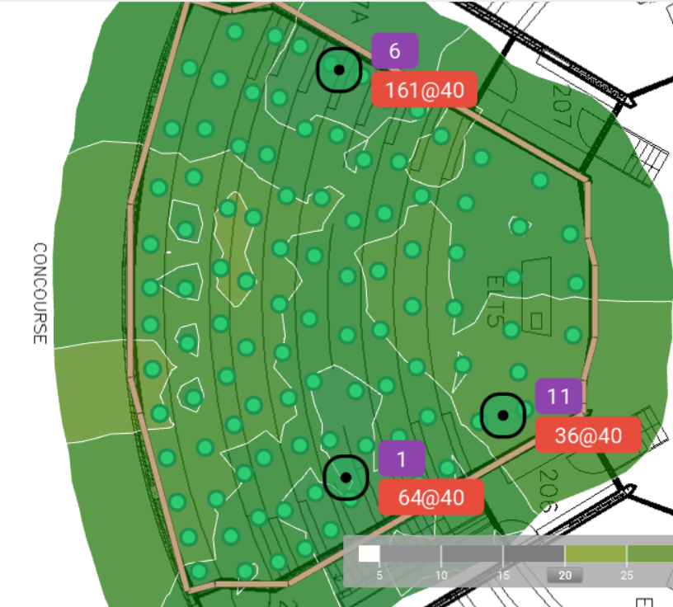

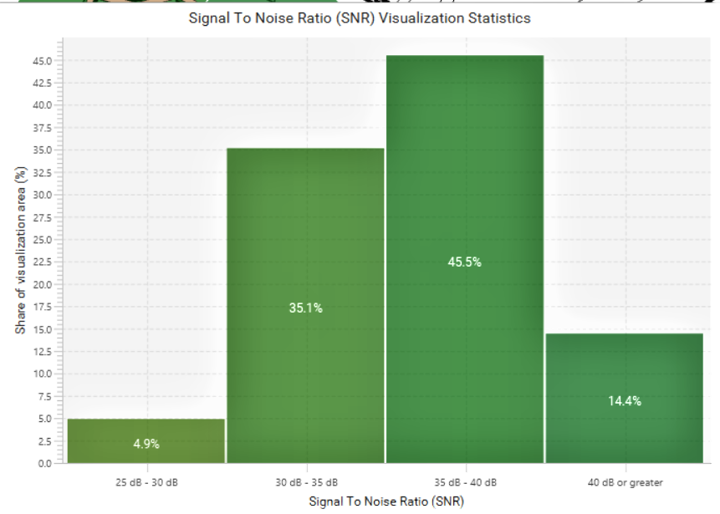

5Ghz:

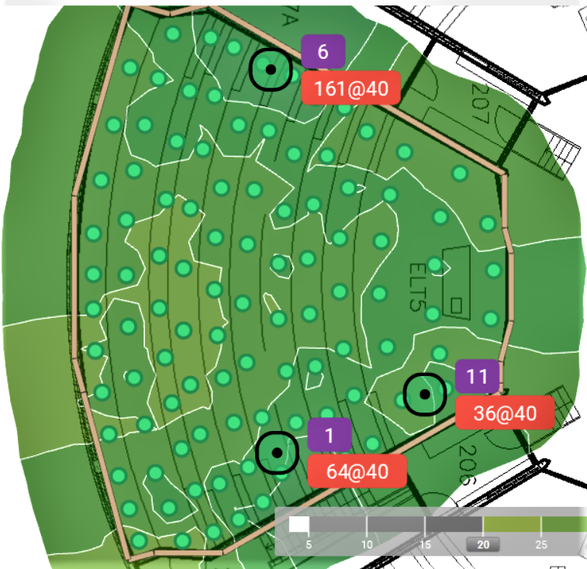

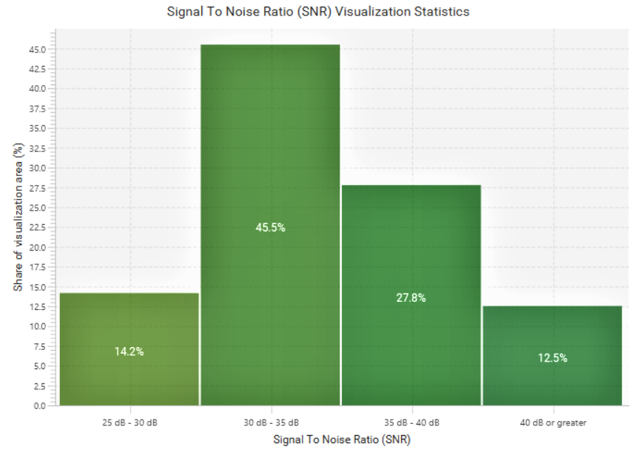

In the above graphs for SNR values for both 2.4Ghz and 5Ghz in Elt5, we can clearly see that some portion of area where SNR value is low which means more noise and less signal strength but in this graph we have acceptable SNR values which is more than 25dB so we need not we worry much about this.

ELT 6:

2.4Ghz:

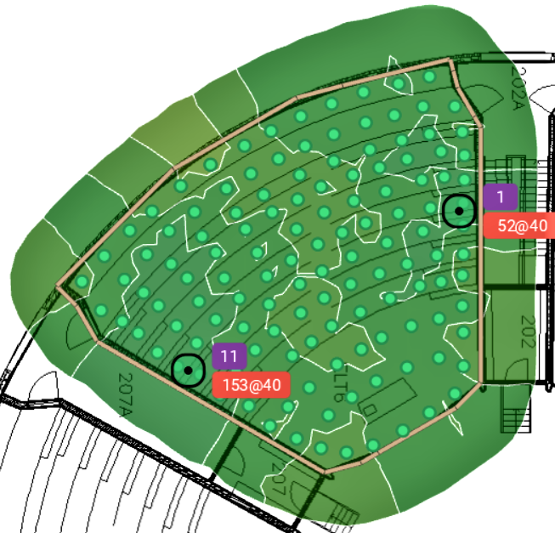

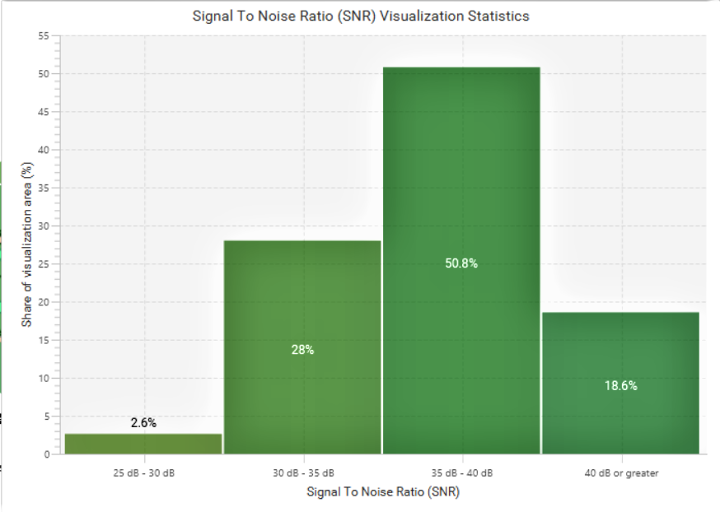

5Ghz:

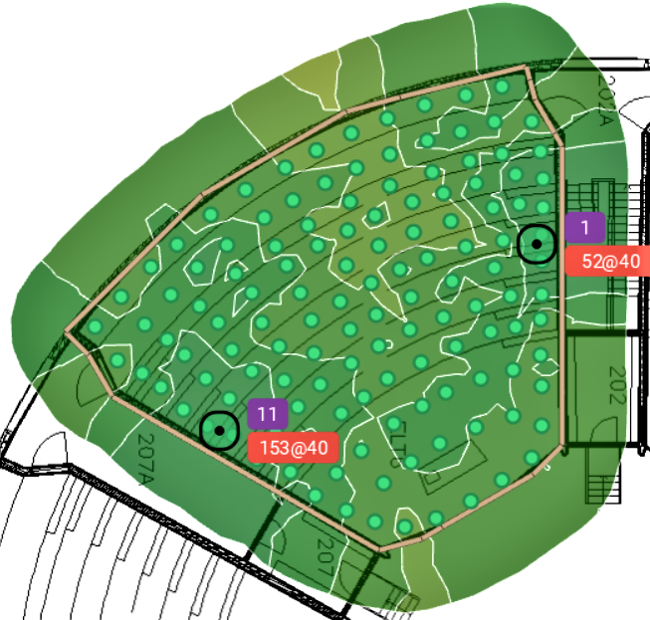

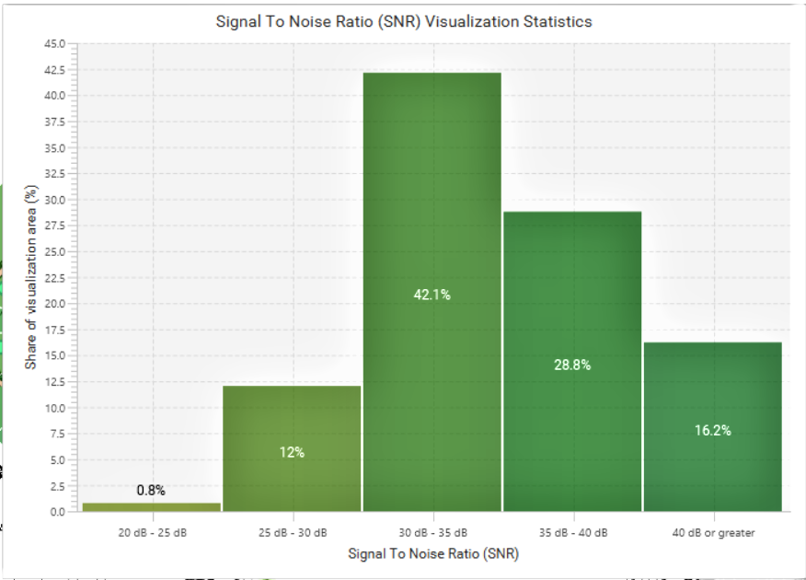

In the above graphs for SNR values for both 2.4Ghz and 5Ghz in Elt6, we can clearly see that some portion of area where SNR value is low which means more noise and less signal strength but in this graph we have acceptable SNR values which is more than 20dB so we need not we worry much about this.

6.2 CHANNEL INTERFERENCE:

ELT5:

5Ghz:

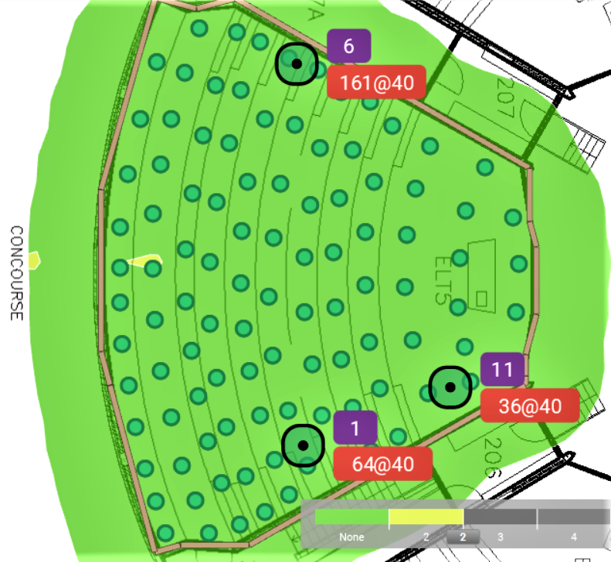

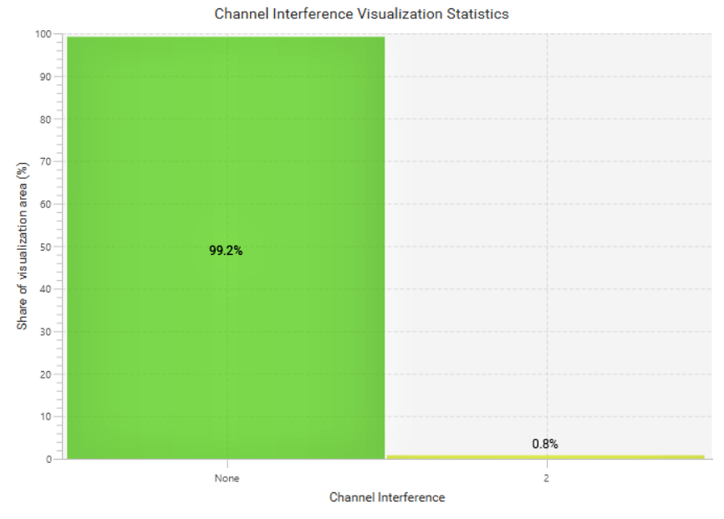

2.4Ghz:

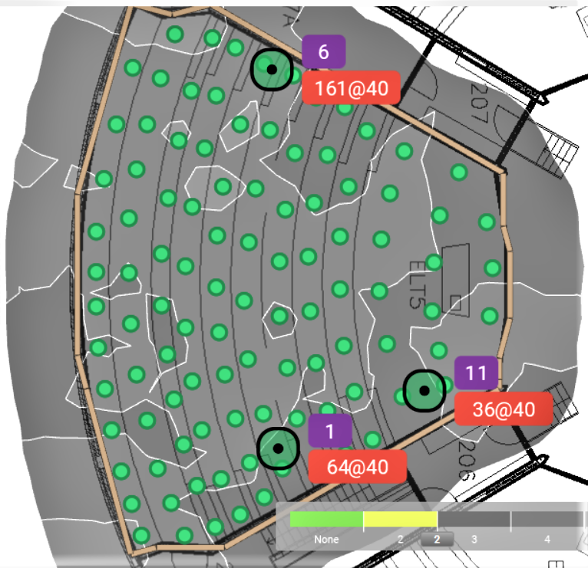

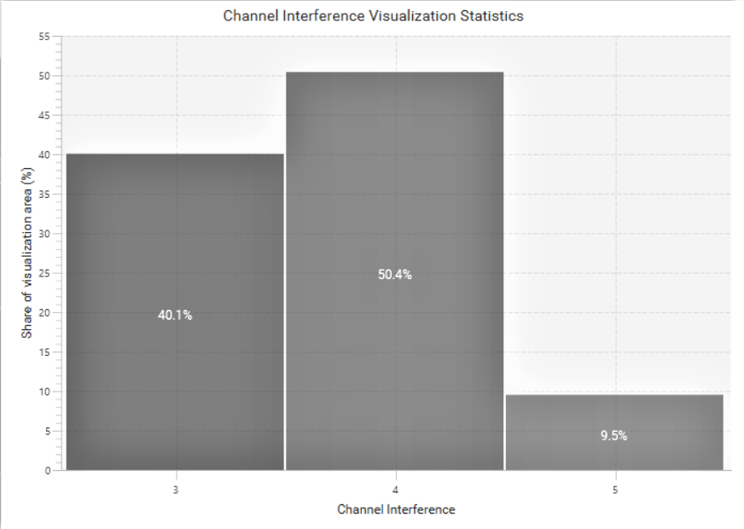

From the above graphs for interference we can clearly state that in 2.4 Ghz signal we are able to see a large interference this is due to the co-channel interference caused by a signal from channel 7 from the adjacent lecture theatre. This can be clearly seen in the interference maps which are listed below. But whereas when we see the interference graphs for 5Ghz we did not encounter any interference.

ELT6:

2.4Ghz:

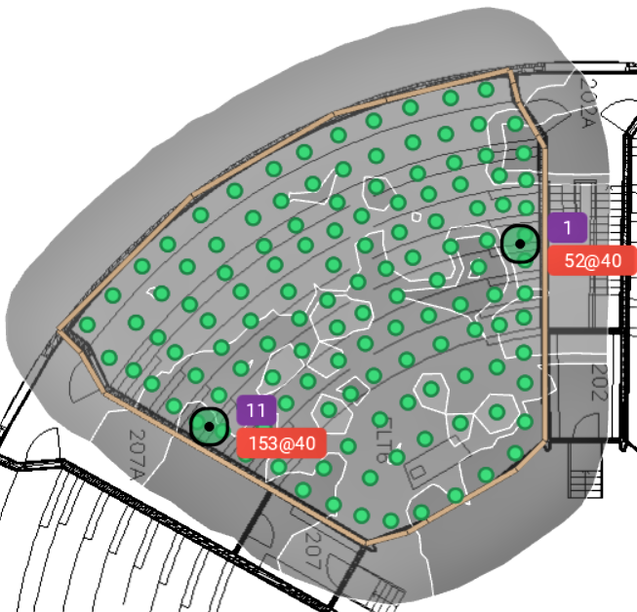

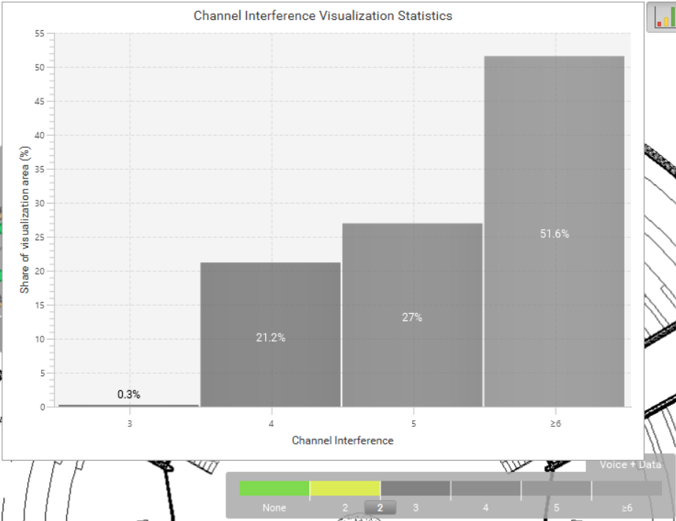

5Ghz:

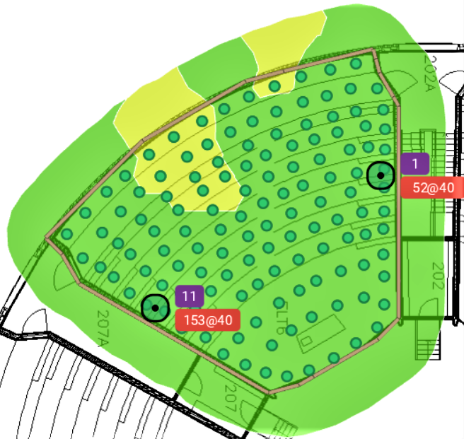

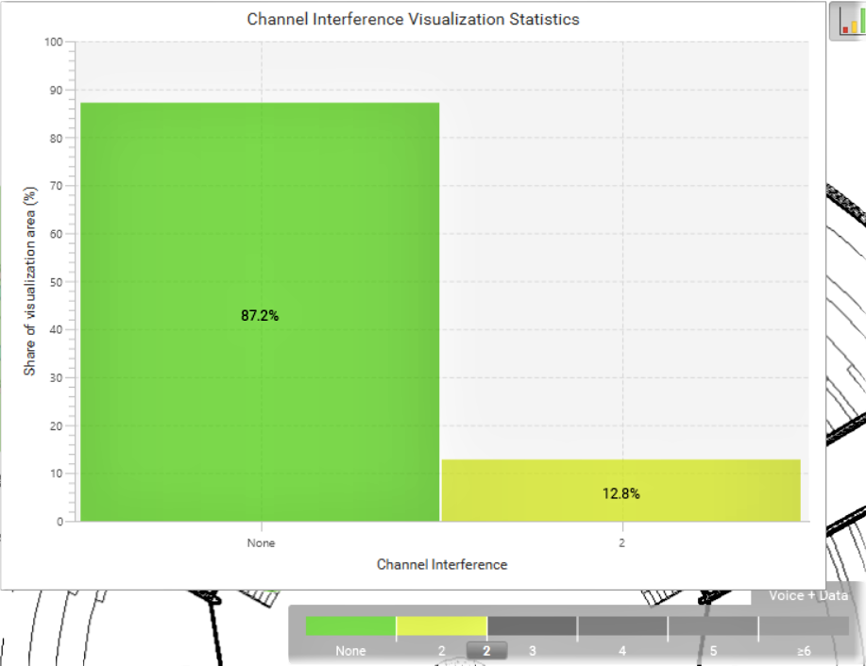

From the above graphs we can clearly see an interference that is present in the 2.4Ghz frequency which is due to an adjacent channel interference caused due to a rogue access point that has been detected in the lecture theatre. This rogue AP will be clearly visible when analyzing the interference graphs in the later portion of this report. But whereas when we see the 5Ghz graph there is a very negligible amount of interference in the signal

6.3 SIGNAL STRENGTH:

Looking in to the signal strength we measure it in dBm scale which we consider -30dBm signal to be the best signal available in the network which is available up to very few feet of Access point while any signal greater than -65dBm considered to be the minimum strength of the signal where we may need to install an access point.

ELT5:

2.4Ghz:

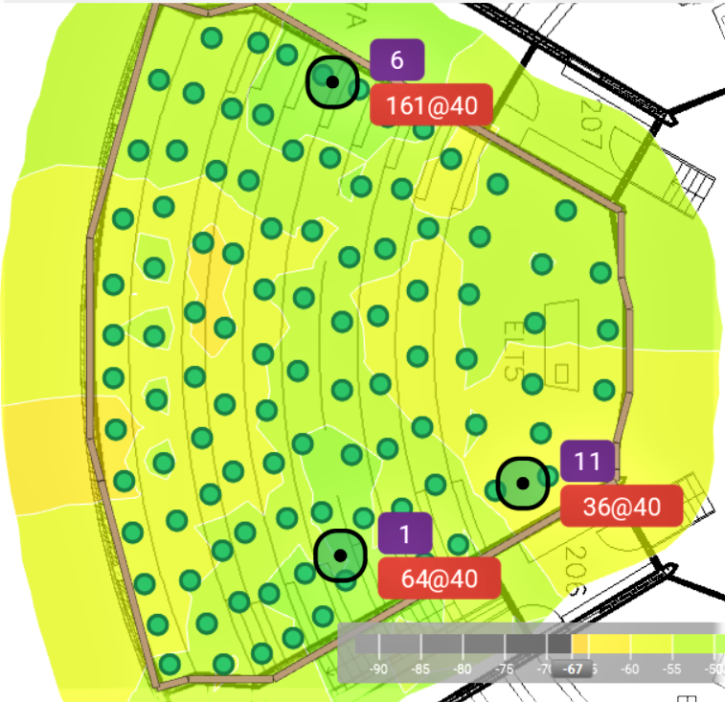

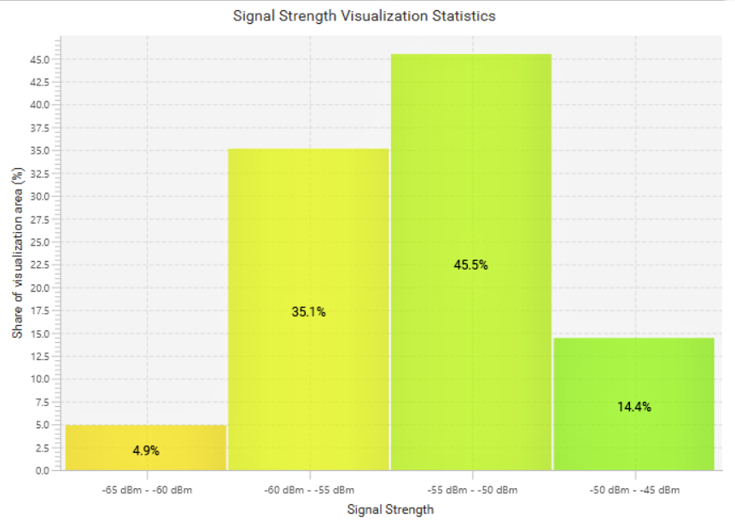

5Ghz:

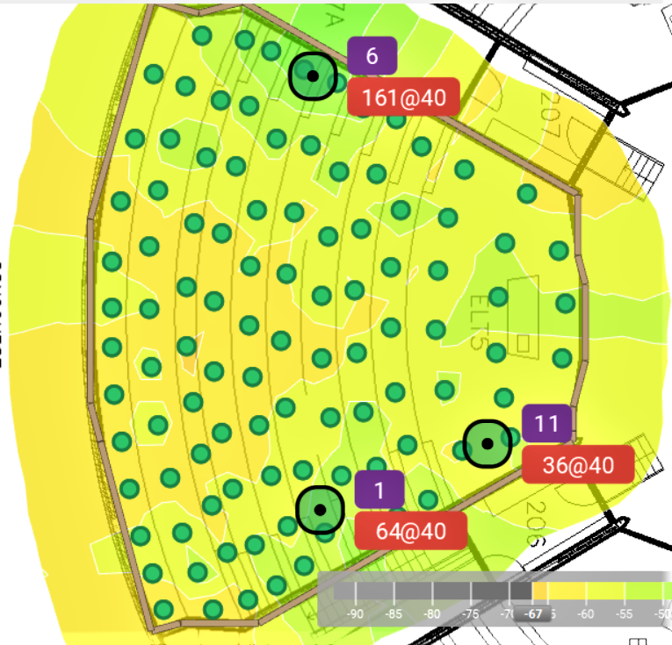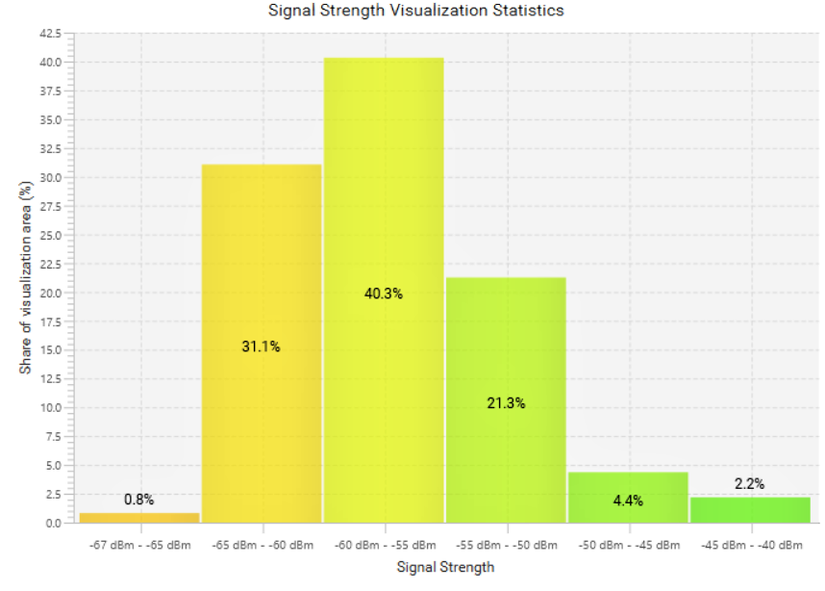

From the above signal strength graphs we can clearly see that the top portions of the lecture theatre are experiencing very low signal strengths. which means location of the Aps has to be altered so that all portions of the theatres receives same amount of signal.

ELT6:

2.4Ghz:

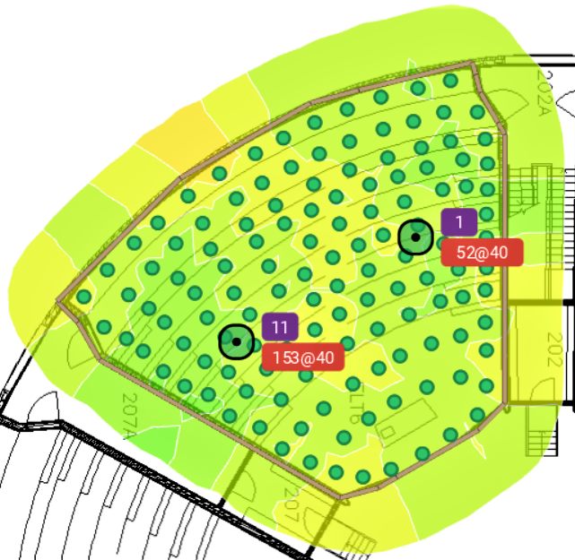

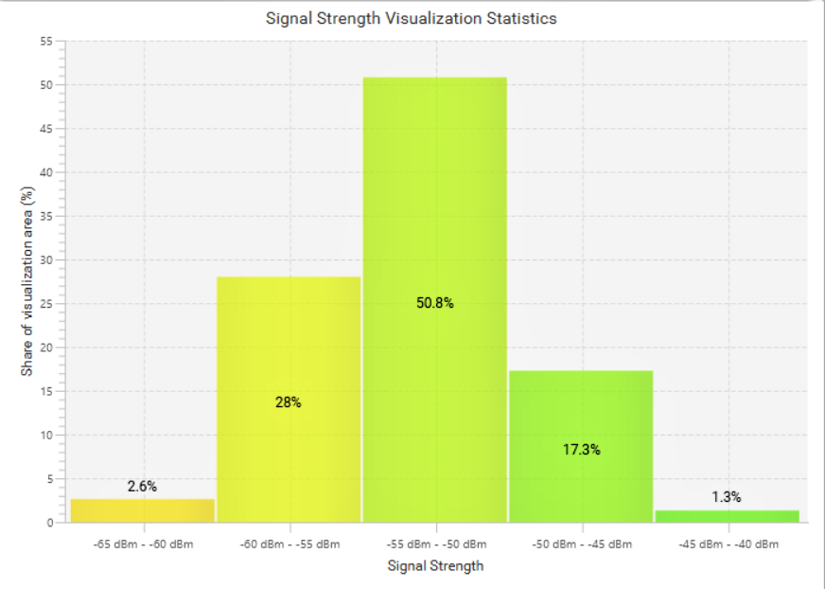

5Ghz:

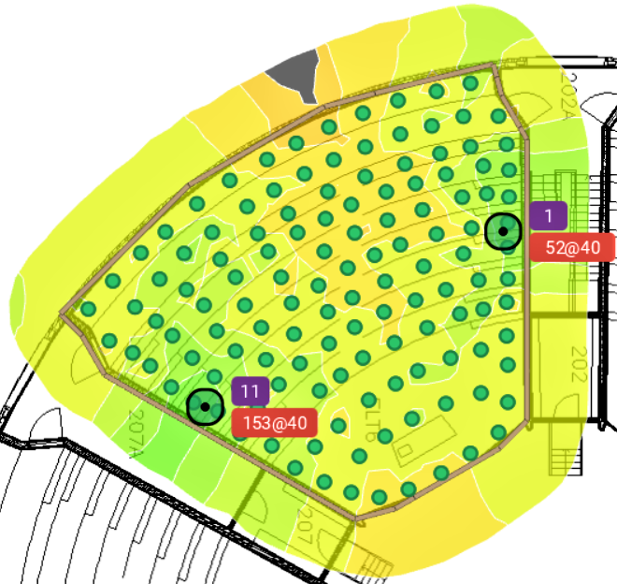

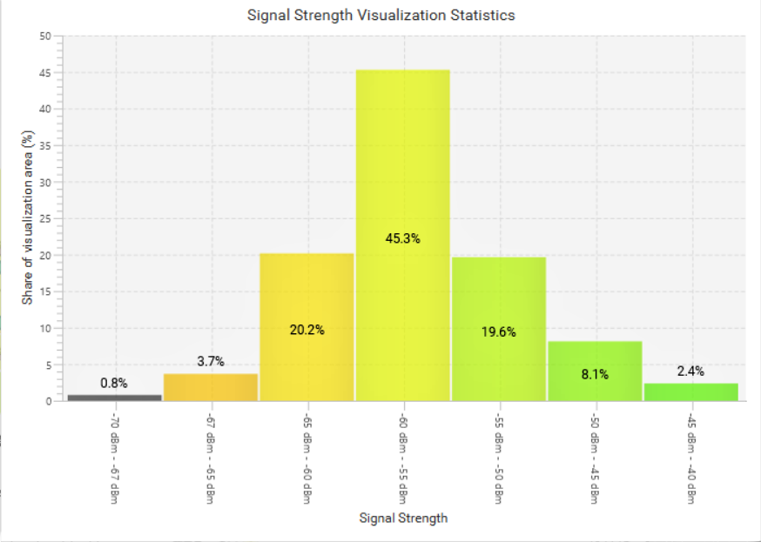

From the above signal strength graphs we can state that the 2.4Ghz signal has no major issues with its signal strength as all the portions in the hall are very well covered but where in with the 5Ghz signal there are portions of the where the crowd will be accumulated has a very weak signal strength. So inorder to increase the signal strength in these areas we need to increase the transmitted power corresponding to 5Ghz.

6.4 THROUGHPUT:

ELT5:

2.4Ghz:

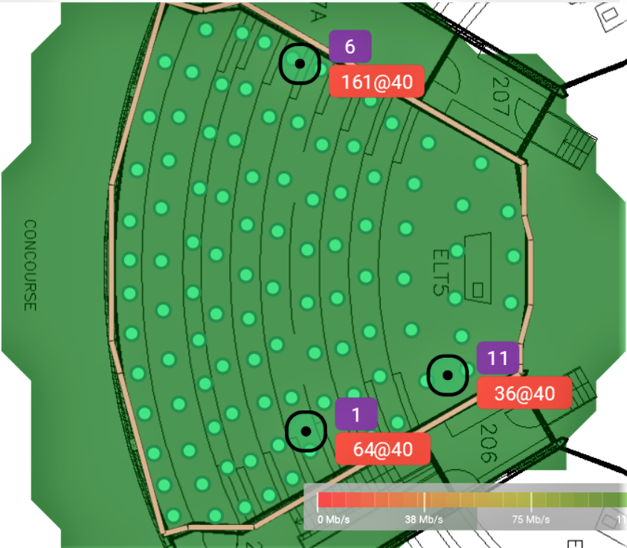

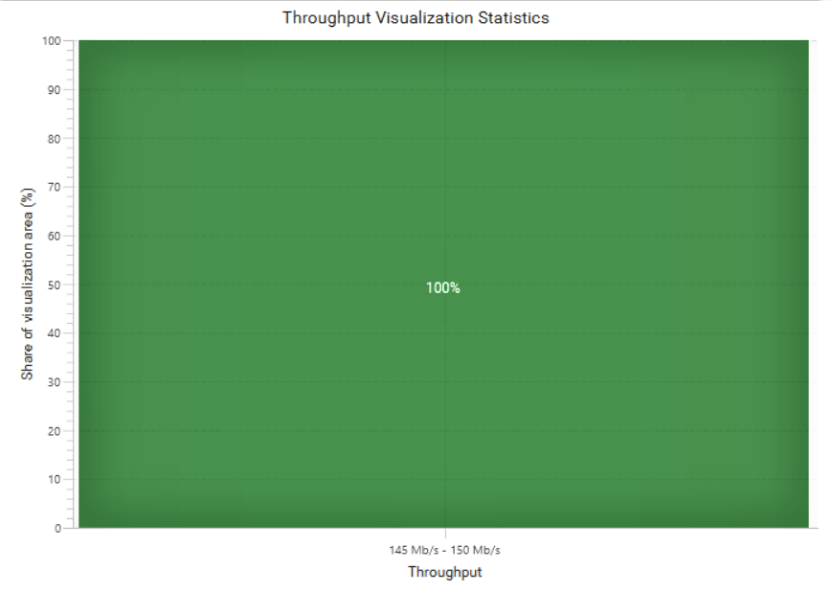

5Ghz:

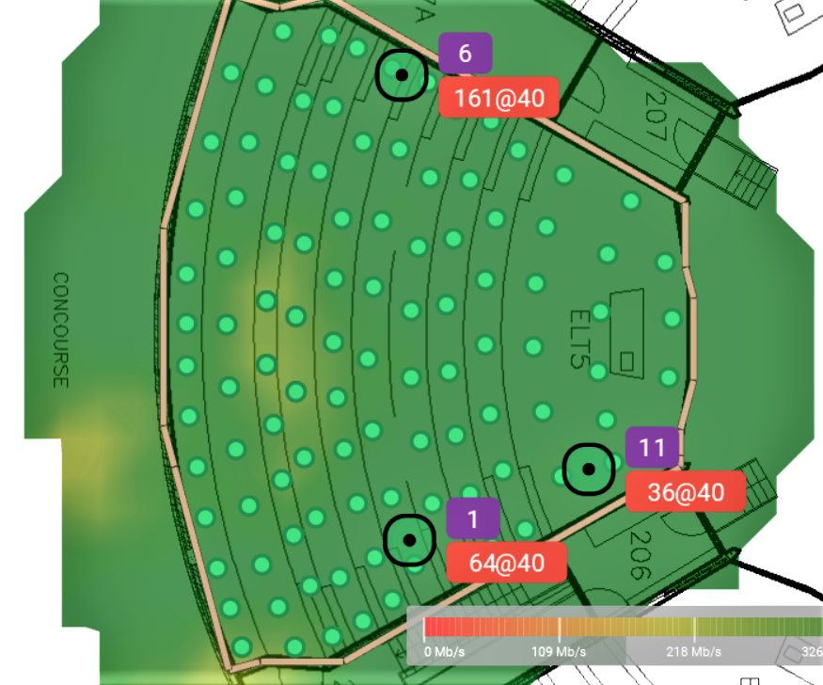

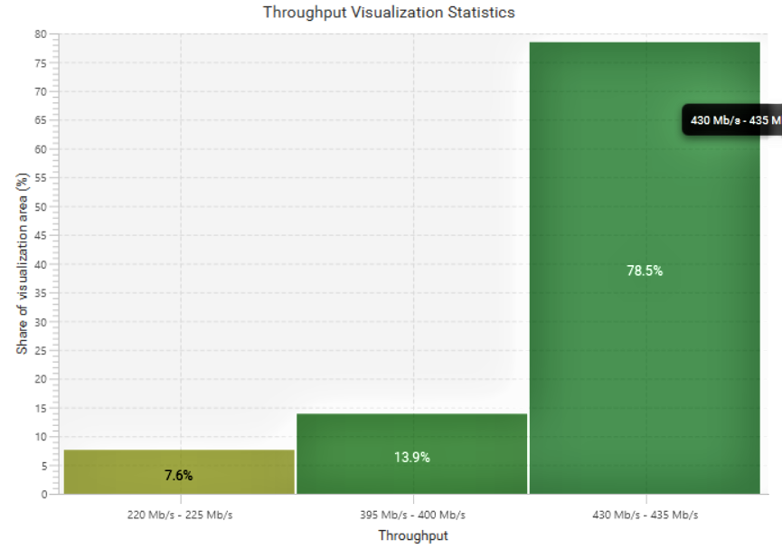

ELT 6:

2.4Ghz:

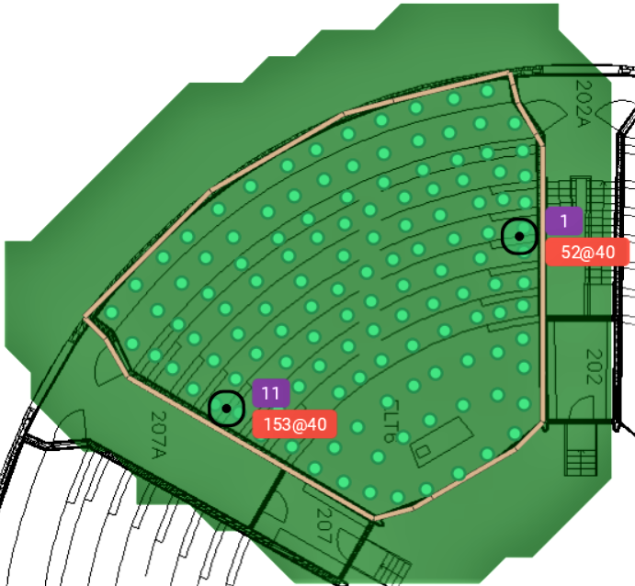

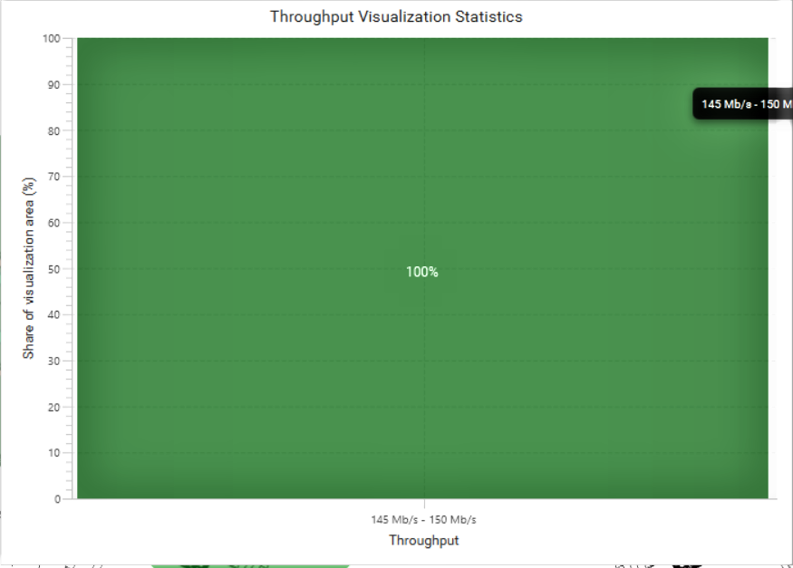

5Ghz:

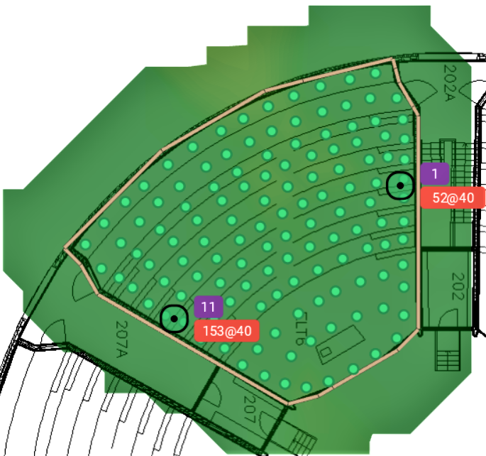

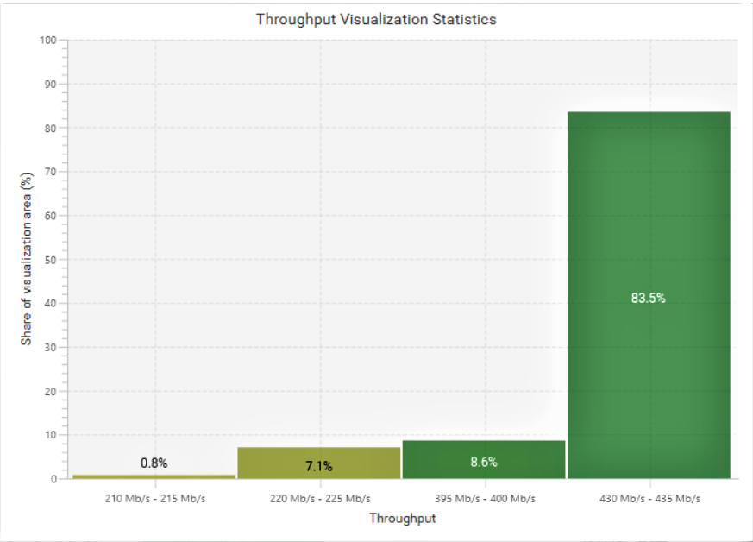

6.5 INTERFERENCE GRAPHS:

ELT5:

2.4Ghz:

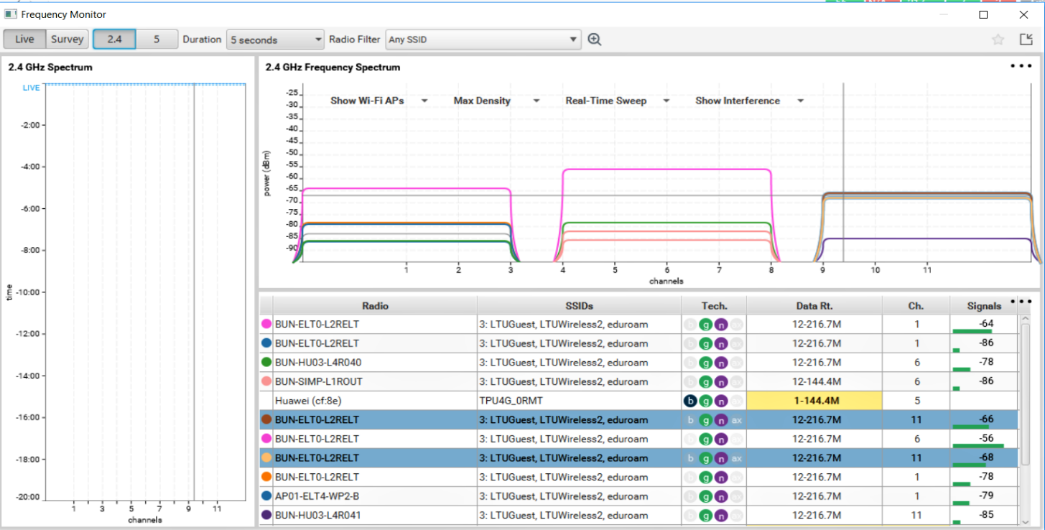

From the above graph analysis we can clearly see interference of two channels belonging to channel 11 overlap each other which means a co-channel interference is taking place in this lecture theatre which caused the 2.4Ghz channel interference to be very high. So, in order to reduce this interference we need to configure the Aps to different channels so that we can avoid this co-channel interference by increasing the distance between the channels.

5Ghz:

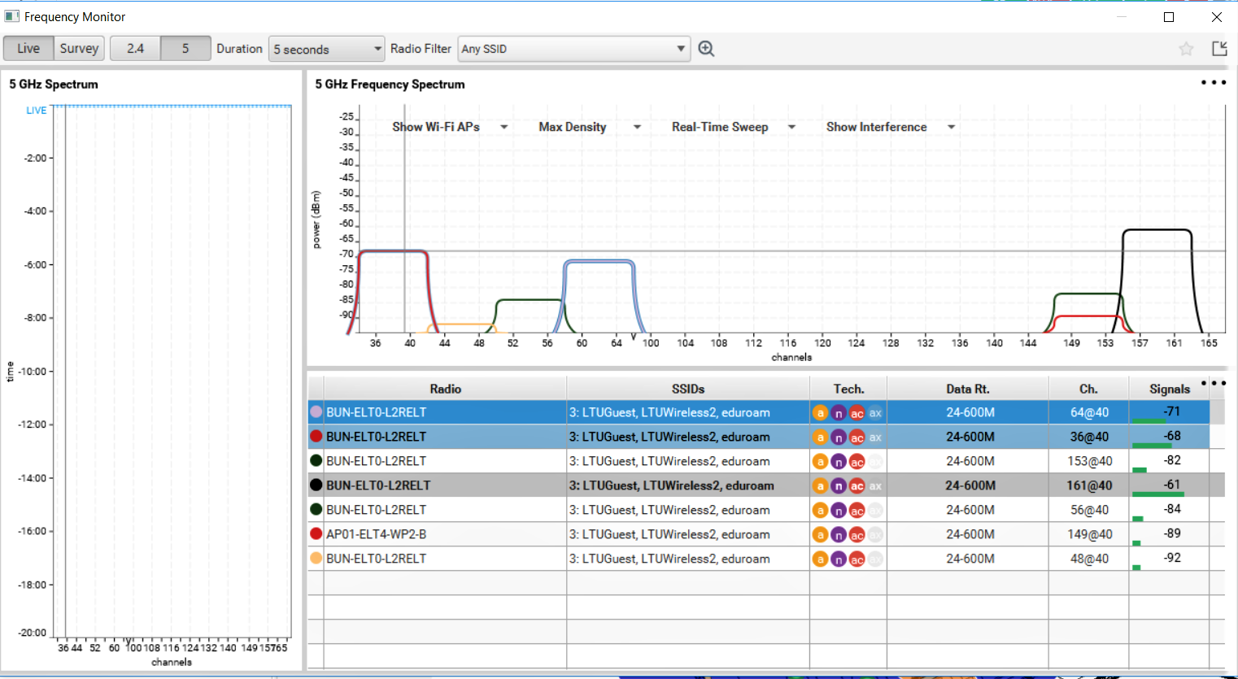

From the above graph we can see that there is a adjacent channel interference which is taking place but at a very negligible signal strength which is why we did not encounter a major interference when we see the interference visualization graph.

ELT6:

2.4Ghz:

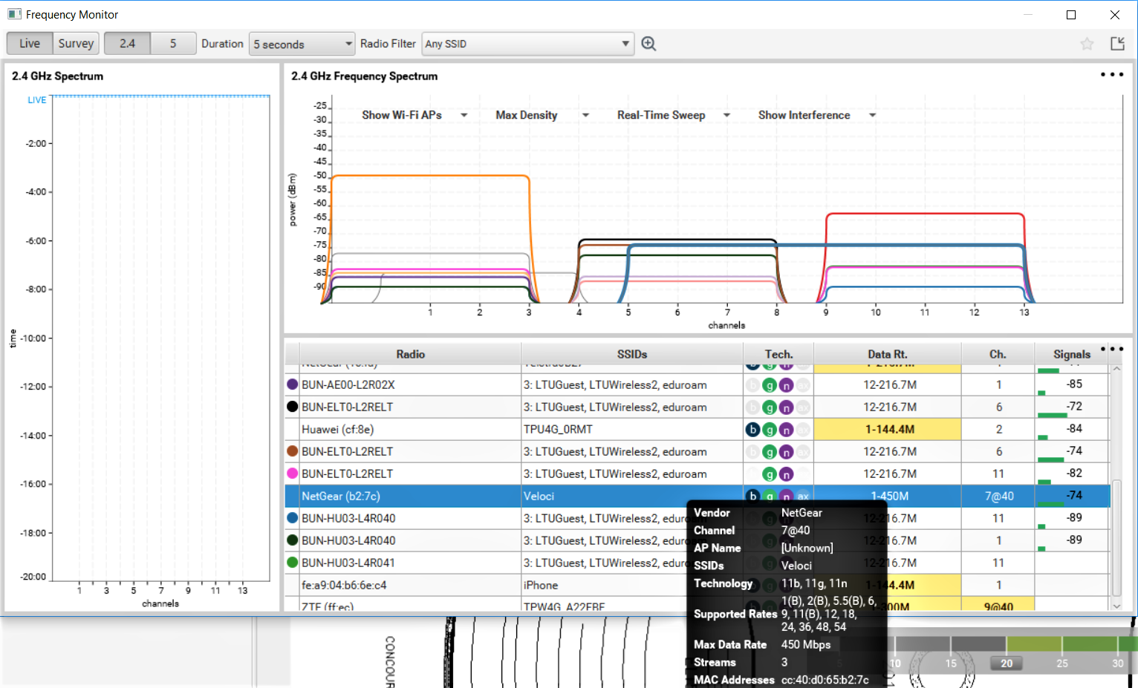

In the above graph we can clearly see a rogue Ap intervening the channels 6 and 11 which we call it a adjacent channel interference which is taking place because the rogue Ap is also transmitting at a 2.4Ghz frequency.

5Ghz:

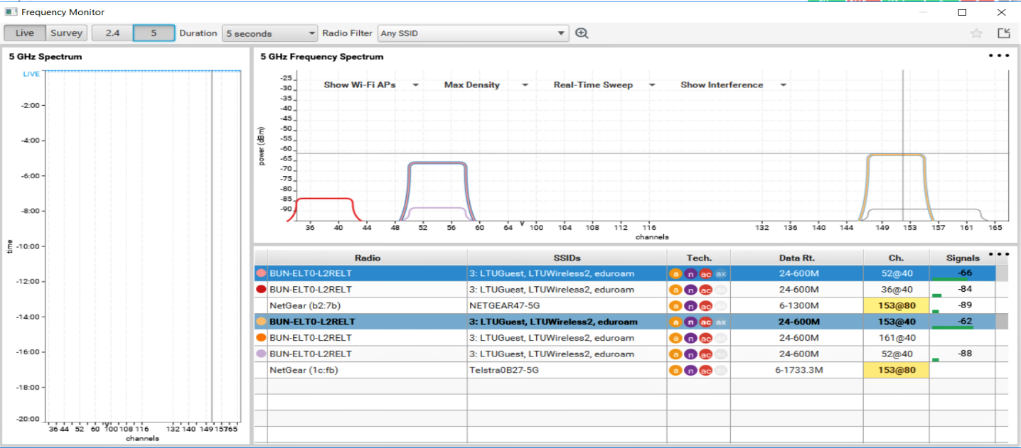

In the above graph we did not encounter ant co-channel or adjacent channel interference. Even when visualizing the overview map for interference we did not encounter any interference in the map.

SURVEY OVERVIEW:

ELT6:

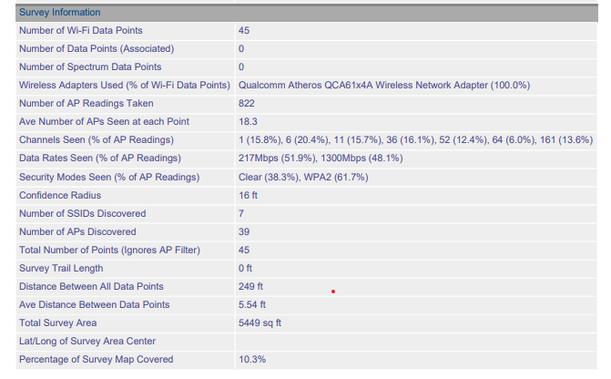

ELT5:

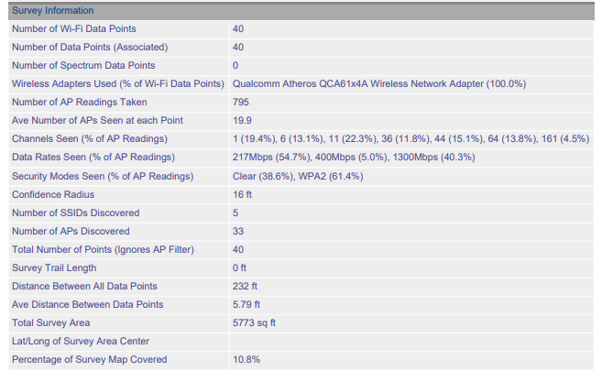

ACCESS POINTS:

ELT5:

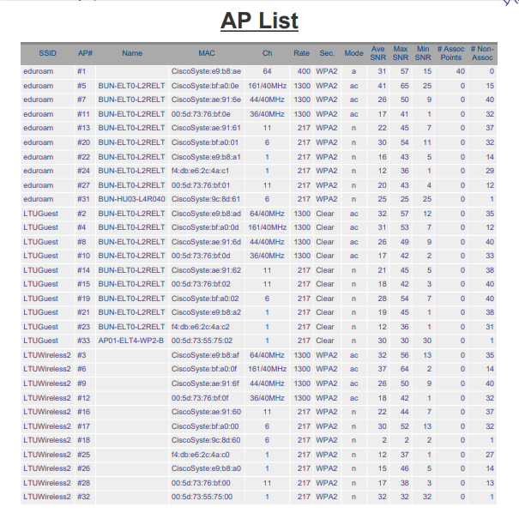

ELT6:

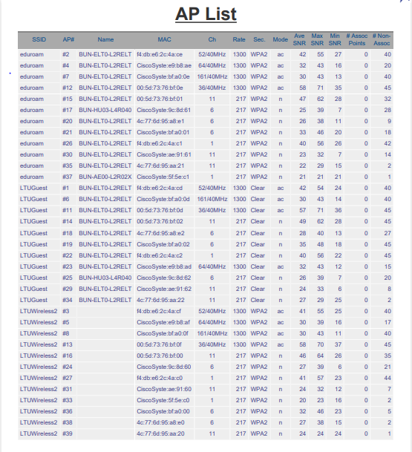

These are the total access points associated to different channels and frequencies of both 2.4Ghz and 5Ghz that are been identified by using visiwave in both the lecture theatres 5 and 6

7 HD BANDWIDTH ESTIMATION:

The capacity of AP is defined by the number of devices an AP can handle simultaneously. To make an approximate value of AP capacity, we need to consider the approximate number of users in ELT5 and ELT6. As the seating capacity in both the lecture theatres is 200 and we also need to take in to consideration the approximate number of devices. So, considering the number of users and devices we will make an approximation on the AP capacity:

Maximum capacity of the theatre is 200. Number of devices per user is 2 (Laptop and Smartphone). Devices are capable of 150mbps for Laptops and 30mbps for Smartphone. We will assume the application throughput of 1Mbps.

Calculating the Airtime required for the above mentioned devices Considering 1 mobile phone 1/30=3.33 per device

Considering 200 mobile phones 3.33*200=666%

Considering 1 laptop 1/150=0.66%

Considering 200 laptops 0.66*200=133%

Therefore we get a 800% required bandwidth to cover the entire lecture theatre for its capacity.

Adding up these two we get the total airtime to be 800% that is we will need 8 access points in approximate if the AP’s are capable of 100Mbps airtime and if we consider the hall to be at it’s maximum capacity is achieved. Since, it’s an approximation we will not have this case in the real scenario we will not have a maximum capacity in the hall according to our physical site survey.

According to our physical site survey the maximum number of clients that we encountered that have a maximum use of devices are 28 laptops and 39 mobiles

Calculating the airtime for this we get  
considering 39 mobile phones 3.33*39 = 129.87%

Considering 28 laptops 0.66*28=18.48%

Therefore we require a 148.35% bandwidth according to our survey.

Adding up these two we get a total air time of 148.35 which requires 2 access points in approximate if the Aps are capable of 100Mbps airtime. So we can say that the hall is equipped with sufficient number of Access points.

8 ANY PROBLEM IDENTIFIED:

After doing a detailed analysis on the network we are able to find that in ELT 5 there is a co-channel interference that existed due to channel 7 in 2.4Ghz frequency range which is having interference with channel 7 from the adjacent lecture theatre.

Coming to the signal strength, there are some sections of the lecture theatre that are receiving very weak signal strength especially at the back part of the lecture theatre with signal strength less than –60dBm which is very weak.

9 POTENTIAL SOLUTION:

Our solution for the problems mentioned above would be a change in the channel 7 that is interfering with the channel 7 in the ELT 5 to any other channel (1,6) so that we can avoid the signals to have co-channel interference.

And coming to the signal strength we can come across two solutions which includes movement of Access points to a better position to provide better signal strength in the weaker portions of the lecture theatre or to include an access point with low power and with a very angle that it does not interfere with the other access points would be the other solution.

10 COST ESTIMATION:

The detailed cost estimate for the proposed solution would be

Employee Cost:

|  |  |
| --- | --- |
| Job | Hourly Wage |
| Site Survey | AUD 30.88 |
| Project Manager | AUD 35.00 |
| Project Designer | AUD 33.00 |

Cost of materials:

|  |  |  |  |
| --- | --- | --- | --- |
| No. | ITEM NAME | QUANTITY | PRICE |
| 1. | Cisco aironet  4800-wireless access point | 1 | A$ 1573 |
| 2. | Cables(CAT_6A) | 10 | A$236.9 |
| 3. | Visiiwave site survey - tool | - | A$849 |
| 4. | Technician | 4 | A$2400 |
|  |  | Total price | A$5058.9 |



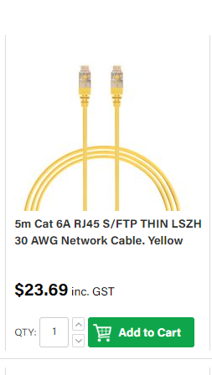



REFERENCES:

* <https://www.ekahau.com/products/heatmapper/overview/>
* <https://www.acrylicwifi.com/en/wlan-wifi-wireless-network-software-tools/wifi-analyzer-acrylic-professional/>
* <https://www.acrylicwifi.com/en/wlan-wifi-wireless-network-software-tools/wlan-scanner-acrylic-wifi-free/>
* <https://www.acrylicwifi.com/en/>
* <https://www.caida.org/research/performance/bandwidth/>
* <https://www.cisco.com/c/en/us/td/docs/wireless/controller/technotes/8-7/b_wireless_high_client_density_design_guide.html>
* <https://www.cisco.com/c/en/us/products/collateral/wireless/aironet-1250-series/design_guide_c07-693245.html>